
Name ____________________

Calculator Assumed Notes Permitted

Marks available: 21 Time allowed: 25 minutes

1. [3 marks]

Using the quadratic formula 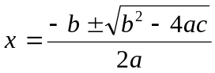 or otherwise, determine the exact solutions to 2x² − 2x + 25 = 0.

2. [5 marks: 1, 2, 2]

If w = 5 − 3i and c = 2 + i determine exactly in the form a + bi
i. c² ii. 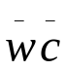 iii. 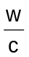

3. [4 marks]

The Argand diagram below shows the complex number z. On the same diagram plot and label the four complex numbers given by 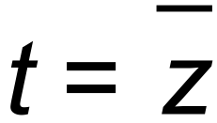 , u = i z , v = i³ z, w = z².
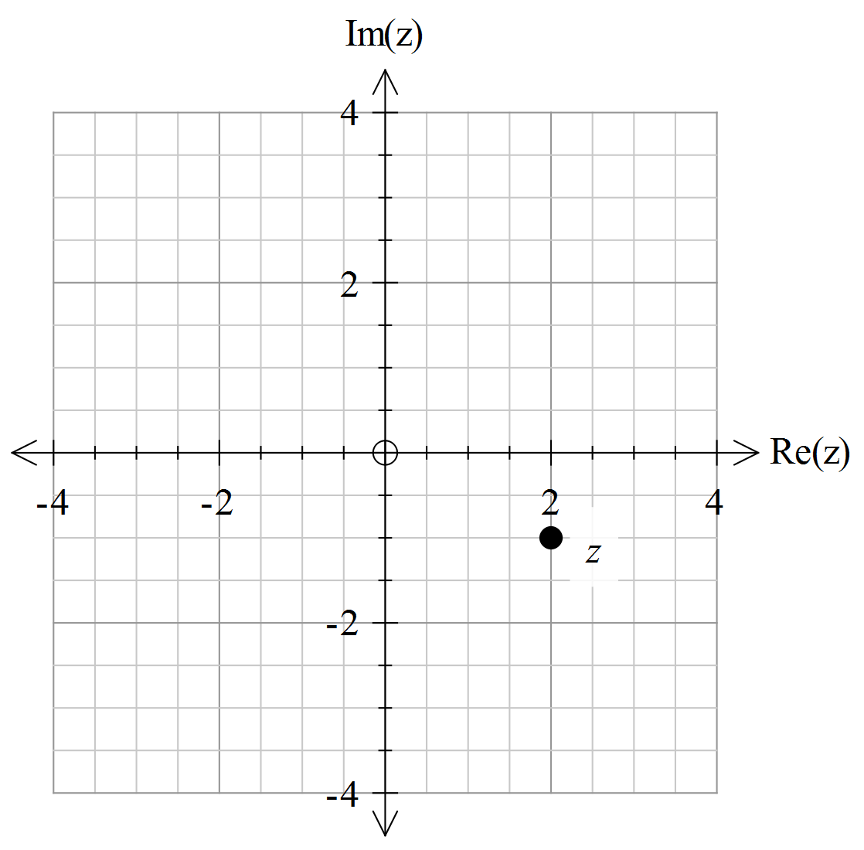

4. [4 marks]

Prove by contradiction that 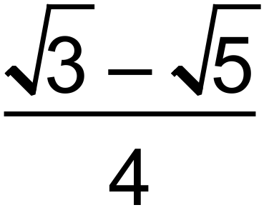 is irrational.

5. [5 marks: 1, 4]

The variables k and m are both positive integers such that m² + 3 = 2k .

i. Explain why m must always be odd.

ii. Using the fact that an odd integer can be written in the form 2n +1, or otherwise,
prove that k is always the sum of three square numbers.

